
334 Amsterdam Avenue at 76th Street
New York, NY 10023
1.646.505.4493
www.jccmanhattan.org

Press Contact: Gerilyn Shur, Allied Integrated Marketing, GShur@AlliedIM.com, office: 646-500-8728
Samantha Kessler, office: 646.505.4493, cell: 330.503.0993

FOR IMMEDIATE RELEASE

JCC Manhattan's 10TH ANNUAL OTHER ISRAEL FILM FESTIVAL ANNOUNCES COMPLETE PROGRAM LINEUP
Festival Boasts Israel’s Most Unique Cinematic Voices for Film Series Held on December 1 – 8, 2016 Slated films highlight stories of Palestinian and other minority groups living in Israel, ranging from Palestinian hip-hop in Lod, racism on the soccer field, co-existence and much more…

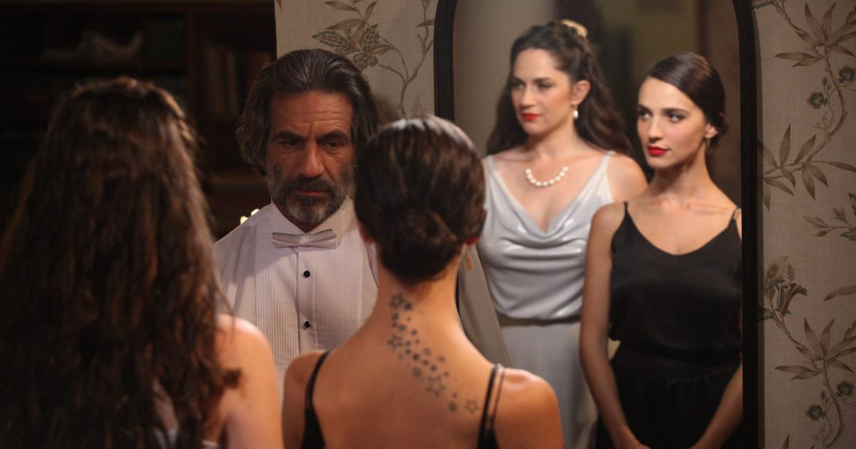
Harmonia – Other Israel Film Festival Opening Night Film
October 10, 2016 (New York, New York) – JCC Manhattan’s Other Israel Film Festival announces the complete lineup of feature and short films for the 10th Annual Other Israel Film Festival held in New York on December 1 – 8, 2016. A diverse selection of award-winning films round out the festival’s 2016 slate; all celebrating unique stories that highlight the best of Israeli directors and artists, while showcasing a full spectrum of Israeli and Palestinian life and culture.
The Other Israel Film Festival, which provides a platform to engage and face some of the challenges within Israeli society through film and dialogue, seeks to foster social awareness and cultural understanding. “We are thrilled to mark ten years of curating dynamic and inclusive forums for exploration of tough themes related to Israeli society,” says Ravit Turjeman, ‎Director of the Other Israel Film Festival & Fund. “As in past years, we will continue to encourage cinematic expression and creativity that truly celebrate the humanity and daily lives of Arab citizens and other minority groups who are most often overlooked by mainstream culture.”
Harmonia, recently awarded the Jewish Experience and Best Cinematography awards at the Jerusalem Film Festival and was nominated at the Israeli Film Academy, is the festival’s opening night film. Closing the festival on December 8 is Cannes Film Festival celebrated feature film Personal Affairs.
Commemorating its ten-year milestone, The Other Israel Film Festival is proud to announce the renaming of the JCC Manhattan film center on opening night, honoring festival founder and JCC Board Member, Carole Zabar.
“In a time when Israeli filmmakers feel artistic limitations enforced by a hawkish ministry of culture, we are seeing our best line up to date,” says Isaac Zablocki Executive Director of the Other Israel Film Festival. “Clearly, the voice of the other has not been silenced in Israeli cinema and is stronger than ever.” The lineup boasts a record number of feature films and more internationally recognized films than any year to date.
The 10th Annual Other Israel Film Festival runs from December 1 – 8, 2016 at JCC Manhattan on 76th St and Amsterdam Ave, as well as at the newly opened JCC Harlem and other locations throughout the city. Tickets are available for sale starting October 10. For additional information, please visit: www.OtherIsrael.org.
The full list of 2016 festival titles includes:

A.K.A. NADIA
Dir. Tova Ascher
2015 | 115 min | Narrative
US PREMIERE
Nadia is a 20-year-old Arab woman having a secret love affair with Nimer, a PLO activist. They move to England, where Nimer is caught by the authorities, leaving Nadia on her own. A shady character provides her with a Jewish woman’s Israeli passport, allowing her to return to Israel. Twenty years later, Nadia is Maya, a successful choreographer married to Yoav, a Jewish official at the Ministry of Justice. When Nimer reappears in Jerusalem, Nadia’s past catches up with her, forcing her to deal with an identity crisis played out against the region’s political backdrop.
Trailer: https://www.youtube.com/watch?v=9HUEYK3-T48&list=PL0DHmN3Yz3eqaLqoGMVbkIlQbmf7ZXEQJ&index=1

BETWEEN WORLDS
Dir. Miya Hatav
2015 | 115 min | Narrative
US PREMIERE
When Bina and Meir visit their son Oliel, hospitalized in Jerusalem after a terror attack, they form a bond with Amal, a young Arab woman, seemingly there to attend to her dying father. As the truth unfolds, they all struggle to accept the unlikely circumstances that have brought them together.
Trailer: http://jerusalemfilmfund.com/film/%D7%90%D7%9E%D7%90%D7%9C/

BEYOND THE MOUNTAINS AND THE HILLS
Dir. Eran Kolirin
2016 | 90 min | Narrative
US PREMIERE
David is discharged from the army after serving 27 years. He finally returns to his family and tries to find himself in his new civilian life. When a friend suggests working for a company that markets dietary supplements, David sees this as an opportunity to get his foot in the door of the business world and make something out of himself. But this decision slowly gets him and his family entangled in the web of dark forces that rule life in Israel. In theaters March 2017.
Trailer: https://www.youtube.com/watch?v=PZnQolbKKJk&index=2&list=PL0DHmN3Yz3eqaLqoGMVbkIlQbmf7ZXEQJ

FOREVER PURE
Dir. Maya Zinschtein
2016 | 86 min | Documentary
Beitar Jerusalem is the most popular and controversial soccer team in Israel–the only club in the Israeli Premier League never to sign an Arab player. Midway through the 2013 season, a secretive transfer deal by the owner brings in two Muslim players from Chechnya. That deal inspires the most racist campaign in Israeli sports, sending the team spiraling out of control. A look at one season in the life of this famed team provides a window into Israeli society, personal identity, money, and power, showing how racism can destroy a team and society from within.
Trailer: https://www.youtube.com/watch?v=itz24M70KTM&index=3&list=PL0DHmN3Yz3eqaLqoGMVbkIlQbmf7ZXEQJ

HARMONIA
Dir. Ori Sivan
2016 | 98 min | Narrative
US PREMIERE
Sarah, a morose harpist in the Jerusalem Philharmonic Orchestra, is married to Abraham, the charismatic conductor of the group. They have no children. When Hagar, a young horn player from East Jerusalem joins the Orchestra, Sarah's world erupts. A unique friendship develops between the two women. Hagar, sympathizing with Sarah’s pain, offers to have a baby for Sarah. Ismail, born to Hagar and Abraham, is a wild and gifted pianist whom Sarah raises as her own. When Ismail discovers the true identity of his mother, his world–and that of those around him–falls apart. Unearthing the metaphoric roots of the conflict, Harmonia maintains the essence of the biblical story from Genesis and adds a unique perspective.
Trailer: https://www.youtube.com/watch?v=ABwGpET-RdM&list=PL0DHmN3Yz3eqaLqoGMVbkIlQbmf7ZXEQJ&index=4

HOLY ZOO
Dir. Katharina Waisburd
2015 | 60 min | Documentary
US PREMIERE
In Jerusalem’s Biblical Zoo, Israelis and Palestinians work side by side to tend to the elephants, crocodiles, and rhinos. Tensions across animal species are reflected in the mostly good-natured but always edgy interactions between employees, who lead regular tours of schoolchildren through the zoo. These tours, given to Jewish and Muslim students, are led separately, with each group learning different details about the same animals; hearing stories constructed to reflect the glories and struggles of the children’s distinct yet neighboring cultures. Katharina Waisburd’s keen eye discovers an extraordinary place in the heart of the Holy Land, daring to revive questions about freedom and hope in a desperate situation.
Trailer: n/a

JUNCTION 48
Dir. Udi Aloni
2016 | 97 min | Narrative
In Lod, a poor town east of Tel Aviv where Arabs and Jews live side by side, Kareem spends his days wandering aimlessly between jobs. When a car accident kills his father, Kareem finds refuge in the world of hip-hop. At a concert, his girlfriend Manar’s lyrics incite an attack from Jewish rappers; and at home, the government threatens to pull down a friend’s house. Kareem and Manar decide to use their songs to fight both oppression and the violence that exists within their own conservative community. Kareem is played by Tamer Nafar, the charismatic frontman of DAM, the first Palestinian rap group. He and Israeli director Udi Adoni transform his personal experiences into the voice of a new generation, full of hope for equal rights and peaceful coexistence. Tribeca Film Festival Award Winner. In theaters February 2017. See SPECIAL EVENTS for concert info.
Trailer: https://www.youtube.com/watch?v=QIvssCjqZi4&index=5&list=PL0DHmN3Yz3eqaLqoGMVbkIlQbmf7ZXEQJ

LAND OF THE LITTLE PEOPLE
Dir. Yaniv Berman
2016 | 83 min | Narrative
US PREMIERE
Four children who live in a village of military officers’ families form a gang, turning an abandoned army base into their camp. When another war begins in Israel and most men are drafted, the kids return to their camp in the wild. To their surprise, they discover two soldiers who deserted their units and are using their camp as a hideout. The children try to regain control over their stolen territory, but the soldiers hold their ground. A ruthless struggle develops between the two groups, and the soldiers, who once sought refuge from the war outside, now find themselves involved in another war, which turns out to be just as dangerous and bloody as the first. With gripping cinematic language, Berman’s feature provides a chilling reminder of the implications that constant conflict can have for a society.
Trailer: https://www.youtube.com/watch?v=eRqL89xJ1YY&list=PL0DHmN3Yz3eqaLqoGMVbkIlQbmf7ZXEQJ&index=6

NAZARETH CINEMA LADY
Dir. Nurit Jacobs Yinon
2015 | 52 min | Documentary
US PREMIERE
The story of Safaa Dabour, an observant Muslim woman from Nazareth, struggling to take charge of her own fate and freedom and to establish the first and only Arab cinematheque in Israel. A single woman in a man's world, Safaa travels to bring Arab box-office hits from Arab states, and seeks against all odds to create an island of culture for the society to which she belongs. Nazareth Cinema Lady is a cinematic profile of a courageous woman.
Trailer: https://www.youtube.com/watch?v=bLSbWeeeq00&list=PL0DHmN3Yz3eqaLqoGMVbkIlQbmf7ZXEQJ&index=7

PERSONAL AFFAIRS
Dir. Maha Haj
2016 | 90 min | Narrative
US PREMIERE
In this witty and modern family drama, a Palestinian family’s personal affairs unfold. In Nazareth, an aging couple lives wearily to the rhythm of the daily routine. On the other side of the border, in Ramallah, their son Tarek wishes to remain an eternal bachelor, their daughter is about to give birth, her husband lands a movie role, and their grandmother loses her head. Between checkpoints and dreams, frivolity and politics, some want to leave and others want to stay, but all have personal affairs to resolve. Official Selection, 2016 Cannes Film Festival.
Trailer: n/a

SAND STORM
Dir. Elite Zexer
2016 | 87 min | Narrative
SPECIAL PRESENTATION
As wedding festivities get underway in a Bedouin village in Israel, Jalila finds herself in the awkward position of hosting her husband Suliman’s marriage to a second, much younger wife. During the celebration, Jalila stumbles upon her daughter Layla’s involvement with a boy from her university—a forbidden liaison that would shame the family, which Jalila tries to clamp down on and is met with resistance from Layla. Sand Storm is a story of tradition, modernity, and divided family that upends expectations. Elite Zexer’s directorial debut portrays the emotionally layered relationship between mother and daughter, both bound by custom while struggling to adapt to a changing world. Zexer’s artful storytelling derives its authenticity, complexity, rich detail, and subtle humor from the 10 years she spent interacting with Bedouin women.
Trailer: https://www.youtube.com/watch?v=kN4OLechCyg&list=PL0DHmN3Yz3eqaLqoGMVbkIlQbmf7ZXEQJ&index=8

THE WRITER
Created and written by Sayed Kashua
Dir. Shay Capon
2016 | 71 min | TV Drama
US PREMIERE
Following the success of Arab Labor, Sayed Kashua returns with another autobiographical series. The Writer centers on Kashua’s fictional self, Kateb, who, after achieving runaway success with the television series Arab Labor, has become the poster boy for the new age Arab-Israeli, able to shift seamlessly between two cultures. Rather than bask in the glory of his rarefied status in Israeli society, Kateb increasingly feels trapped in the gilded cage he has created for himself by living through his alter ego. The series offers an exploration of the hybrid Israeli-Palestinian existence and the personal and political toll it can take.
Trailer: https://www.youtube.com/watch?v=RQ9XTZyd_OI&index=9&list=PL0DHmN3Yz3eqaLqoGMVbkIlQbmf7ZXEQJ

THE 90 MINUTE WAR
Dir. Eyal Halfon
2016 | 85 min | Narrative
US PREMIERE
A comic mockumentary based on the book by Itay Meirson. The Israeli-Palestinian conflict has lasted 100 years. One hundred years of war, bloodshed, bitterness, and suffering. One hundred years of stalemate, intransigence, and failed peace deals. And now, it's all over. They've finally found the solution: A game of soccer. The winner gets to stay. The loser leaves forever. And no whining.
Trailer: https://www.youtube.com/watch?v=MR9uqJolOqM&list=PL0DHmN3Yz3eqaLqoGMVbkIlQbmf7ZXEQJ&index=10

NEW VOICES 2016 - SHORT FILM SELECTION

FACING THE WALL (Dir. Alamork Davidian, 26 min, Narrative)
Surni, a young Ethiopian woman, wakes up heartbroken in an Israeli absorption center. She keeps her eyes and ears closed, trying to shut out her new reality. As the hours go by, her mother helps her say goodbye to the world they left behind.

KEYS (Dir, Hadar Reichman, 11 min, Narrative)
Aziz and his sister are living in the mixed city of Lod. On Saturday, two Jewish Neighbors ask Aziz to move their blocked car. Mayhem ensues when Aziz tries to teach his sister not to be afraid of Jews.

TAKE 3 (Dir. Ayelet Bechar, 15 min, Documentary)
A Palestinian refugee returns to visit his destroyed village near Ramle in 1969, and is filmed for an Israeli documentary. Thirty years later, by an amazing coincidence, he is filmed visiting the same village again. Take 3 returns to these documentaries through the eyes of their directors. Could the same scene be filmed for the third time?

